IDYLLWILD FIRE PROTECTION DISTRICT ANNEX

MULTI-JURISDICTIONAL LOCAL HAZARD MITIGATION PLAN
August 2013
Prepared by: Patrick Reitz, Fire Chief

CONTACT INFORMATION

Idyllwild Fire and Protection District

Name: Patrick Reitz, Fire Chief
Address: P.O. Box 656/ 54160 Maranatha Drive
City State and Zip: Idyllwild, CA 92549
Telephone: 951-659-2153
E-Mail: Chief@idyllwildfire.com

PLAN ADOPTION/RESOLUTION
The Idyllwild Fire Protection District will submit plans to Riverside County Fire – Office of Emergency Services who will forward to CAL EMA for review prior to being submitted to FEMA. In addition, we will wait to receive an “Approval Pending Adoption” before taking the plan to our local governing bodies for adoption. Upon approval, the Idyllwild Fire and Protection District will insert the signed resolution.

EXECUTIVE SUMMARY
The purpose of this local hazard mitigation plan is to identify the County’s hazards, review and assess past disaster occurrences, estimate the probability of future occurrences and set goals to mitigate potential risks to reduce or eliminate long-term risk to people and property from natural and man-made hazards.
The plan was prepared pursuant to the requirements of the Disaster Mitigation Act of 2000 to achieve eligibility and potentially secure mitigation funding through Federal Emergency Management Agency (FEMA) Flood Mitigation Assistance, Pre-Disaster Mitigation, and Hazard Mitigation Grant Programs.
Riverside County's continual efforts to maintain a disaster-mitigation strategy is on-going. Our goal is to develop and maintain an all-inclusive plan to include all jurisdictions, special districts, businesses and community organizations to promote consistency, continuity and unification.
The County’s planning process followed a methodology presented by FEMA and CAL-EMA which included conducting meetings with the Operational Area Planning Committee (OAPC) coordinated by Riverside County Fire – Office of Emergency Services comprised of participating Federal, State and local jurisdictions agencies, special districts, school districts, non-profit communities, universities, businesses, tribes and general public.
The plan identifies vulnerabilities, provides recommendations for prioritized mitigation actions, evaluates resources and identifies mitigation shortcomings, provides future mitigation planning and maintenance of existing plan.
The plan will be implemented upon FEMA approval.

Table of Contents
CONTACT INFORMATION 1
PLAN ADOPTION/RESOLUTION 2
EXECUTIVE SUMMARY 3
SECTION 1.0 - COMMUNITY PROFILE 5
1.1 IDYLLWILD MAP 5
1.2 GEOGRAPHY AND CLIMATE DESCRIPTION 5
1.3 BRIEF HISTORY 5
1.4 ECONOMY DESCRIPTION 6
1.5 POPULATION AND HOUSING 7
1.6 DEVELOPMENT TRENDS 7
SECTION 2.0 - PLANNING PROCESS 8
2.1 PARTICIPATION IN REGIONAL (OA) PLANNING PROCESS 8
2.2 MITIGATION PLANNING PROCESS 8
2.3 DATES AVAILABLE FOR PUBLIC COMMENT 8
2.4 PLANS ADOPTED BY RESOLUTION 8
SECTION 3.0 – MITIGATION AND HAZARD UPDATES 9
3.1 MITIGATION UPDATES FROM 2005 PLAN 9
3.2 JURISDICTION HAZARDS 9
SECTION 4.0 - HAZARD IDENTIFICATION AND RISK ASSESSMENT 10
4.1 HAZARD REVIEW AND SUMMARY 10
4.2 ESTIMATING POTENTIAL LOSS 10
4.3 CRITICAL FACILITIES AND INFRASTRUCTURES 11
4.4 IDENTIFICATION OF RISKS AND VULNERABILITIES 14
SECTION 5.0 – COMMUNITY RATING SYSTEM 15
5.1 REPETITIVE LOSS PROPERTIES N/A 15
5.2 NATIONAL FLOOD INSURANCE PROPERTIES 15
SECTION 6.0 - CAPABILITIES ASSESSMENT 16
6.1 ADMINISTRATIVE/TECHNICAL MITIGATION CAPABILITIES 16
6.2 FISCAL MITIGATION CAPABILITIES 16
SECTION 7.0 - MITIGATION STRATEGIES 17
7.1 MITIGATION OUTREACH AND PARTNERSHIPS 17
7.2 FUNDING OPPORTUNITIES 17
7.3 GOALS AND OBJECTIVES 17
7.4 MITIGATION PRIORITIES 18
SECTION 8.0 - PLAN IMPLEMENTATION AND MAINTENANCE PROCESS 21
SECTION 9.0 - INCORPORATION INTO EXISTING PLANNING MECHANISMS 21
SECTION 10.0 - CONTINUED PUBLIC INVOLVEMENT 21
APPENDIX A- PLANNING SIGN-IN SHEET 22
APPENDIX B - INVENTORY WORKSHEETS 23
APPENDIX C – PLAN REVIEW TOOL/CROSSWALK 24

PAGE BLANK INTENTIONALLY

SECTION 1.0 - COMMUNITY PROFILE

IDYLLWILD MAP
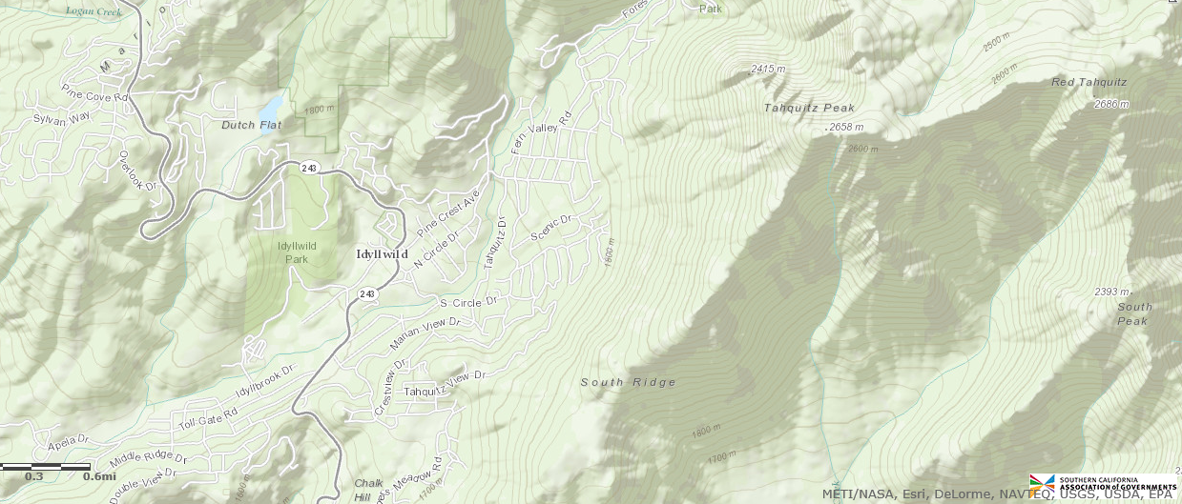

GEOGRAPHY AND CLIMATE DESCRIPTION
The Jurisdiction is a Special Fire District located in the unincorporated mountain community of Idyllwild, Riverside County. It is approximately 5 square miles in area located about 60 miles east of the county seat, the City of Riverside. The community of Idyllwild is surrounded on all sides by the San Bernardino National Forest and is transected from NE to SW by Strawberry Creek. Even though there is a creek running through the community, there is no land that, for disclosure purposes in escrow, would be considered “flood plain”.
The “District” is in mountainous terrain running from 5,000’ to 6,500’ elevation in a mixed conifer forest fuel type. The Clark section of the San Jacinto Fault runs NW to SE and is SW of the community approximately 7 miles at the closest point. The San Jacinto Fault is considered to be the most active fault in Southern California (D.M. Morton and J.C. Matti, USGS 2005, revised 2008)
Idyllwild averages 26 inches of rain per year with some of that falling as snow in three to four storms per winter. Summer thunderstorms also contribute to the rainfall total as well as wildland fires from lightning strikes.

BRIEF HISTORY
The Idyllwild Fire Protection District was formed in 1946 to provide structural fire protection to the rural community of Idyllwild. Various levels of ambulance service evolved and in 1980 were upgraded to Paramedic ALS service.
The wildland fire protection inside the district is provided by the U.S. Forest Service, San Bernardino National Forest under agreement with CAL FIRE.

ECONOMY DESCRIPTION
Our Jurisdiction is primarily a bedroom community. Development in the Community is 90 percent residential, 10 percent commercial, and less than 1% percent light industrial. Fifty-nine percent of the residences are part time and forty-one percent are actually full time residents. The Jurisdiction is funded by a small percentage of County property taxes (fire tax) and a unit fee per parcel inside the fire protection district.
There are no chain restaurants or businesses owned by large corporations so there is no primary employer in Idyllwild and weekend tourists support many of the shops and restaurants. As a result, many of the residents work in the cities surrounding the San Jacinto Mountains.
Figure 1.4.1 Household Income Table
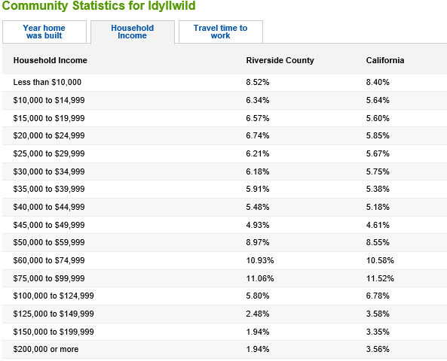

POPULATION AND HOUSING
The population of Jurisdiction from the 2010 Census was estimated at 3,200. This was an increase in the population of 200 in the 2005 plan.

DEVELOPMENT TRENDS
Because the boundaries of Idyllwild Fire Protection District are surrounded by the San Bernardino National Forest, there is little area for expansion of the business district. There are approximately 700 lots still available for new construction but construction is slow because only 41% of the residences are occupied full time with a majority of all residential structures being second homes or recreation rentals.
Figure 1.6.1 – Idyllwild Median Home Sales
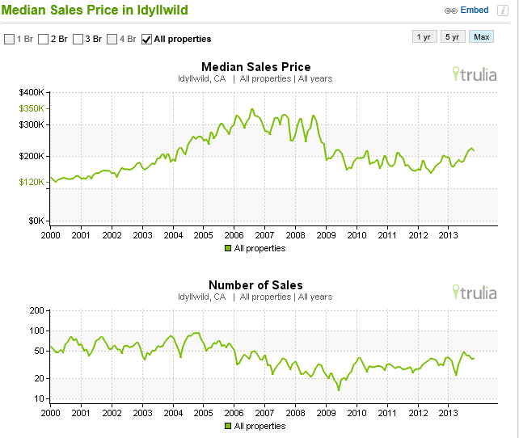

SECTION 2.0 - PLANNING PROCESS

PARTICIPATION IN REGIONAL (OA) PLANNING PROCESS
The Idyllwild Fire Protection District participated in various Riverside County workshops, conferences, and meetings, including: MEMSCOM, and IFPD Board of Commissioners meetings where public comment was sought.
The planning process involved reviewing the following:
- Idyllwild Fire Protection District Ordinance B
- Potential hazards that can impact jurisdiction
- 2005 Local Hazard Mitigation Plan and FEMA Recommendations
- Historical data for prior hazards since approval of 2005 plan
- Mitigation strategies
- Public comments from meetings

MITIGATION PLANNING PROCESS
Since Idyllwild Fire Protection District is a single entity (Special Fire District) and is not combined with any other government function, it falls to the Fire Chief to review the 2005 documents for accuracy and determine the need for updates. The Idyllwild Fire Board of Commissioners reviews and approves the plan.
Coordination of the LHMP was done with the Mountain Communities Fire Safe Council and the Riverside County sponsored MEMSCOM group.

DATES AVAILABLE FOR PUBLIC COMMENT
Presentation of the LHMP planning process for Idyllwild Fire Protection District was held on 11/09/11 at an advertised MEMSCOM Meeting and public comment was also taken at the October and November Board of Commissioners meeting for IFPD.
An opportunity for public comments on the DRAFT mitigation strategies was provided at a public board meeting at Idyllwild Fire Station on:
- November 8, 2011
- December 12, 2011

PLANS ADOPTED BY RESOLUTION
Plan will be adopted by resolution upon FEMA approval.

SECTION 3.0 – MITIGATION AND HAZARD UPDATES

MITIGATION UPDATES FROM 2005 PLAN
The one project listed for the Idyllwild Fire Protection District in 2005 was not done. There was never any money secured for a seismic survey of the Idyllwild fire station, but it is still a viable project and should be done so that the survivability of the building could be predicted in a 6.0 earthquake. The fire department is a gathering place for local citizens and civic groups use the conference room. The conference room is also an ICP and the main building contains an EMS treatment room.

JURISDICTION HAZARDS
There are not any changes or additional hazards since approval of the 2005 plan. The priorities remain the same from prior plan which is earthquake, fire and flood. Our jurisdiction has had State and Federally declared incidents in the jurisdiction.
Unique jurisdiction incident timeline:
1980: Flooded Hwy 74 near Cranston which isolated Idyllwild from western access.
1996: Bee Canyon Fire, Idyllwild and Pine Cove Communities evacuated. Power lost.
2002: Western Pine Bark Beetle Infestation.
2003: Southern California Wildfires
2005: Severe Windstorm Damage, Blow down of trees causing home damage and road closures.
2010: Extreme Weather Damage

SECTION 4.0 - HAZARD IDENTIFICATION AND RISK ASSESSMENT

HAZARD REVIEW AND SUMMARY
The hazards include the same as in much of Riverside County, including earthquake, severe weather (isolation caused by downstream flooding) and fires.
The Idyllwild Fire Protection District has experienced a small number of different disasters over the last 50 years, including downstream flood related isolation, wildfire evacuation; severe storm damage and a Western Pine Bark Beetle infestation for which the County of Riverside is still under a county disaster declaration.

ESTIMATING POTENTIAL LOSS
Statistically, the most vulnerable structures inside the District are located along the west side of the community. The reason is because the historic large wildfires have come from this direction. Steep canyons run west to east up to the community from the higher populated areas of Hemet and the Soboba Indian Reservation.
Along the western edge of the community not all homes would be destroyed by any one wildfire but a professional guess would be that 40 – 60 structures might be a reasonable number in a single event with a value of $15 - $22 million.

CRITICAL FACILITIES AND INFRASTRUCTURES
An inventory of critical facilities in the Community of Jurisdiction.
Table 4.3.1 – Idyllwild Fire Protection District Critical Facilities

Critical Facilities Type | Number
Airports | -
Communications Centers | -
Emergency Command Centers/EOC | -
Fire Departments | 1
Health Care Facilities | 1
Law Enforcement/Detention Facilities | -
County Roads Yard | 1
Schools | 2
Public Utilities—Water/Sewer | 2
Totals | 7

Table 4.3.2 Replacement Values for Critical Facilities
Name of Asset | Replacement Value ($) | Occupancy/ Capacity # | Hazard Specific Info.
IFPD Station 621 | $3,037,500 | N/A | Masonry Const.
Idyllwild Water District | $292,000 | N/A | Earthquake susceptibility
Fern Valley Water District | $100,000 | N/A | Earthquake susceptibility
Idyllwild Health Clinic | $250,000 | N/A | Earthquake susceptibility
Idyllwild School K - 12 HUSD | $10,000,000 | 500 | None
Idyllwild Arts Campus | 40,788,549 | 650 | Open campus forested conditions

4.3.3 Idyllwild Critical Infrastructure Map
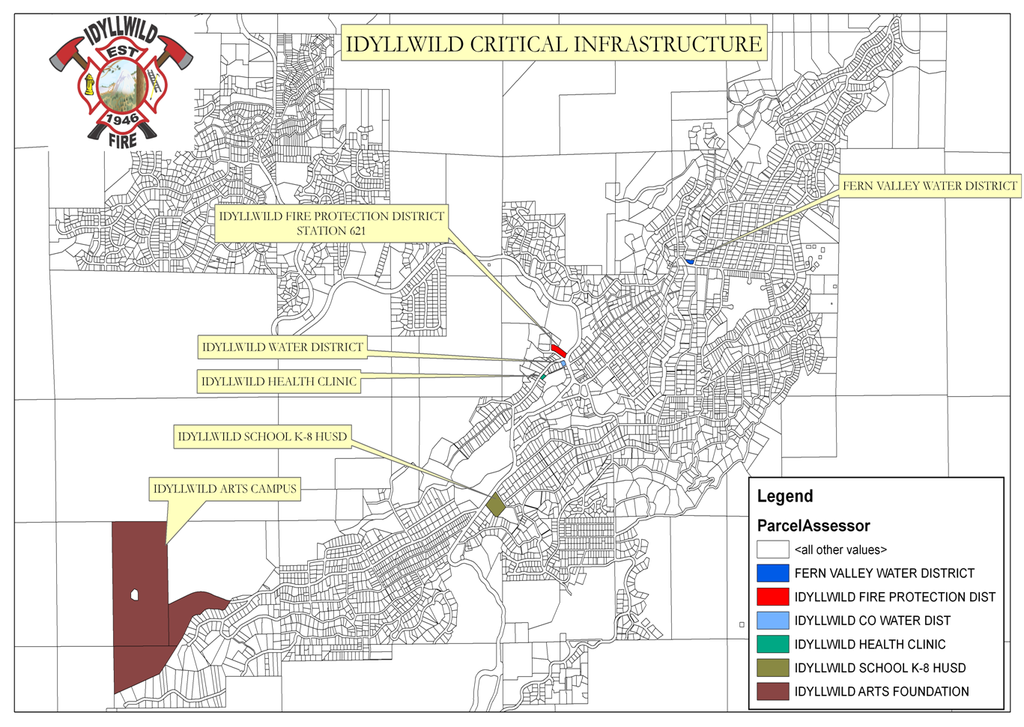

4.4.1 Jurisdiction Vulnerability Worksheet

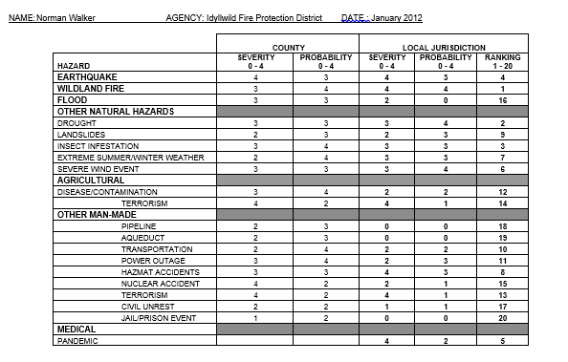

IDENTIFICATION OF RISKS AND VULNERABILITIES
- Wildland Fire – Severity -4, Probability -4, Ranking –1
A wildfire is an uncontrolled fire in an area of combustible vegetation that occurs in the countryside or wilderness areas. Our most prominent threat is along the western edge of the community where homes would be destroyed.
- Drought - Severity -3, Probability - 4, Ranking – 2
The drought itself was weathered well by the jurisdiction through staged water conservation imposed by both Fern Valley and Idyllwild Water Districts. However, the Western Bark Beetle infestation that came with the drought stressed conifer forest caused a state declared emergency that was only recently cancelled by Governor Jerry Brown. Tens of thousands of trees were cut to mitigate fire and falling hazards. (See Riverside County OA MJHMP Section 5.3.5 Pages 227-230)
- Earthquake – Severity - 4, Probability -3 Ranking – 4
An earthquake is a sudden, rapid shaking of the Earth caused by the breaking and shifting of rock beneath the Earth's surface. Jurisdiction is located in a Seismic Hazard Zone. The nearest active earthquake faults are located north of the community (San Andreas) and southwest of the community (Clark section of the San Jacinto fault). The Jurisdiction has experienced several noticeable ground movement incidents, such as from the Landers earthquake and the Loma Priata earthquake, but no local damage was sustained. Masonry construction is not common in Idyllwild but the Idyllwild Fire Station 621 is one of the few. (See Riverside County OA MJHMP Section 5.3.3 Pages 196-218)
- Flood - Severity -2 , Probability -0, Ranking –16
At 5,500 feet the community is located near the headwaters of the San Jacinto River and North Fork of the San Jacinto River. There is no history of flood damage at this elevation but the town can be isolated from road washouts at lower elevations. (See Riverside County OA MJHMP Section 5.3.2 Pages 164-195)
- Severe Weather - Severity -3 , Probability -3 , Ranking –7
Extreme Heat is not an issue. Extreme cold is an issue and the Jurisdiction is part of a Warming Center plan hosted at the American Legion. In 2005 there was a County declared emergency for severe wind damage in Idyllwild and other parts of Riverside County. Trees fell through roofs and severely damaged three homes and caused minor damage to others. (See Riverside County OA MJHMP Section 5.3.4 Pages 219-226 and Section 5.3.8 Pages 239-249)
- Technological Hazards - Severity - , Probability - , Ranking – None.
(See Riverside County OA MJHMP Section 5.4 Pages 271-294)

SECTION 5.0 – COMMUNITY RATING SYSTEM
The District doesn’t participate with National Flood Insurance Program.

REPETITIVE LOSS PROPERTIES N/A

NATIONAL FLOOD INSURANCE PROPERTIES
a. Describe participation in NFIP, including any changes since previously approved plan.
b. Date first joined NFIP.
c. Identify actions related to continued compliance with NFIP.
d. CRS member?
e. CRS class?
f. Describe any data used to regulate flood hazard area other than FEMA maps.
g. Have there been issues with community participation in the program?
h. What are the general hurdles for effective implementation of the NFIP?
i. Summarize actions related to continued compliance with NFIP (c-2 and c-4)
i. Repetitive Loss Properties –

SECTION 6.0 - CAPABILITIES ASSESSMENT

ADMINISTRATIVE/TECHNICAL MITIGATION CAPABILITIES
Personnel Resources | Yes/No | Department/Position
Planner/engineer with knowledge of land development/land management practices | N | Planning and Development Director
Engineer/professional trained in construction practices related to buildings and/or infrastructure | Yes | Fire Marshall
Planner/engineer/scientist with an understanding of natural hazards | No
Personnel skilled in GIS | Yes | Fire Marshall
Full time building official | Yes | Fire Marshall
Floodplain manager | No
Emergency manager | Yes | Fire Chief
Grant writer | Yes | Fire Captain
Other personnel | No
GIS Data—Land use
GIS Data—Links to Assessor’s data
Warning systems/services  (Reverse 9-11, outdoor warning signals) | Yes | Reverse 911 System

FISCAL MITIGATION CAPABILITIES
Financial Resources | Accessible/Eligible  to Use (Yes/No) | Comments
Community Development Block Grants | Yes
Capital improvements project funding | Yes
Authority to levy taxes for specific purposes | Yes | With voter approval
Fees for water, sewer, gas, or electric services | No
Impact fees for new development | Yes
Incur debt through general obligation bonds | No
Incur debt through special tax bonds | No
Incur debt through private activities | No
Withhold spending in hazard prone areas | n/a

SECTION 7.0 - MITIGATION STRATEGIES
The Special Districts coordinated with Riverside County Fire Department, multiple cities and agencies throughout Riverside County in the creation/update of our LHMP Annex. The cooperation and discussions both in regional meetings, community outreach and internal meetings allowed for both “big picture” and “local jurisdiction” views of mitigation needs and possibilities.

MITIGATION OUTREACH AND PARTNERSHIPS
The Idyllwild Fire Department recently agreed to an automatic aid agreement for fire and emergency medical services with the Riverside County Fire. They also have mutual aid agreements with Hemet Fire Department and the U.S Forest Service Fire Management.

FUNDING OPPORTUNITIES
The District has the same funding opportunities as Riverside County Operational Area. Please refer to Section 7.4 and Table 7.4 of the Riverside County Multi-Jurisdictional Hazard Mitigation Plan for list of funding sources available.

GOALS AND OBJECTIVES
Goal #1: Provide Protection for People’s Lives from All Hazards
Objective1.1: Replace critical infrastructures with shake shingle roofing and encourage homeowners to do the same.

Objective1.2: Provide timely notification and directions to the public of imminent and potential hazards.
Goal #2: Educate community about hazards and associated vulnerabilities that threaten our communities.
Objective 2.1: Educate residents about creating defensible spaces for those that live in the Wildland –Urban Interface Zone.

Objective 2.2: Provide Burn Institute Homeowner Guide developed to help residents build defensible spaces, defensible homes and evacuation plans.
Objective 2.3: Encourage residents to install home fire sprinklers
Goal #3: Coordinate with neighboring communities and jurisdictions to share resources.
Objective3.1: Develop Memorandum of Understandings (MOU) to share resources with special districts for mitigation and communications.

MITIGATION PRIORITIES
The Board of Commissioners and Fire Chief of Idyllwild Fire Protection District identified and prioritized the following mitigation actions based on the risk assessment. Background information and information on how each action will be implemented and administered, such as ideas for implementation, responsible office, partners, potential funding, estimated cost, and schedule are included.

1. Enhance Fire Abatement Inspections
Issue/Background: Fire abatement inspections are of paramount importance in containing wildfire within the community. The department cannot fund enough inspectors to handle the 3,700 inspections and two possible re-inspections to obtain compliance.
Other Alternatives: No action = only 1/3 of all inspections completed each year
Responsible Office: Fire Marshall
Priority (High, Medium, Low): High
Cost Estimate: $10,000 labor
$ 2,500 for 2 tablet computers
Potential Funding: FEMA Pre-Disaster Mitigation grants or County Fire Hazard Mitigation Grant
Benefits (Avoided Losses): Elimination of fire prone properties and overstocked sections of forested lands that support crown fire development. Fire behavior would be reduced and home losses minimized.
Schedule: First Spring after funding secured

2. Hardening of Homes
Issue/Background: “Hardening” of Homes. Educate the public of the need to replace flammable siding and original attic and basement vents with fire resistant siding and ember proof vents. Provide grant money through Mountain Communities Fire Safe Council to offset costs to home owners.
Other Alternatives: No Action
Responsible Office: Partnership between IFPD and Mountain Communities Fire Safe Council
Priority: High
Cost Estimate: $500,000
Potential Funding: FEMA Pre-Disaster Mitigation grants or County Fire Hazard Mitigation Grant(s)
Benefits (Avoided Losses): Prevention of home to home transfer of fire through ember showers. Potentially millions of dollars in preventable losses.
Schedule: 3 months after funding secured
3. P-wave Detection System
Issue/Background: The benefit of fire station automatic bay doors opening 30 seconds prior to the actual shaking of an earthquake can be the difference in the ability to respond or not. Since there is only one fire station in Idyllwild, it is imperative that the emergency equipment not be trapped inside the station.
Other Alternatives: No Action, currently the availability is dependent on the earthquake!
Responsible Office: IFPD
Priority: High
Cost Estimate: $30,000
Potential Funding: FEMA Pre-Disaster Mitigation grants or County OES Grant(s)
Benefits (Avoided Losses): Much higher probability of IFPD equipment being able to respond immediately after an earthquake rather than having to cut doors open, delaying the response.
Schedule: 6-8 months after funding secured

4. Replace Wood Shake Siding on Station 621
Issue/Background: Fire Station was built with “treated” wood siding which is too old to be fire resistant. In order to be an example to the community and to have a safer building in a wildfire this siding should be replaced with cement lap siding.
Other Alternatives: No Action
Responsible Office: IFPD
Priority: Moderate
Cost Estimate: $20,000
Potential Funding: FEMA Pre-Disaster Mitigation grants or County OES Grant(s)
Benefits (Avoided Losses): Protection of the superstructure of the fire station.
Schedule: 3 months after funding secured
5. Earthquake Construction Code Compliance Survey
Issue/Background: Station 621 is of masonry construction and needs to be evaluated by an engineering firm to determine survivability of a 6.0 earthquake. The contract would ask for required and/or suggested upgrades to the building. Separate funding would then be sought for that phase of the project.
Other Alternatives: No Action=no guarantee of survivability.
Responsible Office: IFPD
Priority: Moderate
Cost Estimate: Unknown. IFPD would create an RFP
Potential Funding: FEMA Pre-Disaster Mitigation grants or County OES Grant(s)
Schedule: 6 months after funding secured
On-Going Mitigation Strategy Programs:
• CERT training – Sponsored by IFPD in partnership with Mountain Disaster Preparedness
• Mountain Area Safety Taskforce - Interagency
• MEMSCOM – County OES sponsored
• Mountain Communities Fire Safe Council
• Mountain Area Evacuation Plan – Interagency: CAL FIRE/IFPD/U.S. Forest Service/Riverside County Fire Department

SECTION 8.0 - PLAN IMPLEMENTATION AND MAINTENANCE PROCESS
Idyllwild Fire and Protection District will monitor and evaluate our LHMP on a yearly basis. Over the next 5 years, we will review the LHMP and assess, among other things, whether:

- The goals and objectives address current and expected conditions.
- The nature, magnitude, and/or type of risks have changed.
- The current resources are appropriate for implementing the plan.
- There are implementation problems, such as technical, political, legal, or coordination issues with other agencies.
- The outcomes have occurred as expected (a demonstration of progress).
- The agencies and other partners participated as originally proposed.
- If we discover changes have occurred during the evaluation, we will update the LHMP Revision Page, and notify OES to update our Annex.
- Idyllwild Fire and Protection District will be in charge of the monitoring, evaluation and updating of our LHMP.

SECTION 9.0 - INCORPORATION INTO EXISTING PLANNING MECHANISMS
The Idyllwild Fire and Protection District will incorporate the Local Hazard Mitigation Plan into our Fire Abatement Ordinance B.
The enactment of this ordinance is pursuant to the authority of the California Health and Safety Code Sections 13861(h), 13879, Division 12, Part 5, Sections 14875, et seq., and Division 12, Part 6, Section 14930.
Other planning mechanisms to incorporate the LHMP plan is the following:
- Idyllwild Fire and Protection District Emergency Operation Plan
- Capital Improvement Plan
- Water System Master Plan
- 2010 California Code

SECTION 10.0 - CONTINUED PUBLIC INVOLVEMENT
After we go through the Scheduled Plan Maintenance Process, we will notify the public of any changes/no change in the LHMP Plan at the Commissioners’ Meeting and on the districts website.

APPENDIX A- PLANNING SIGN-IN SHEET
LHMP – Meeting Sign-in Sheet

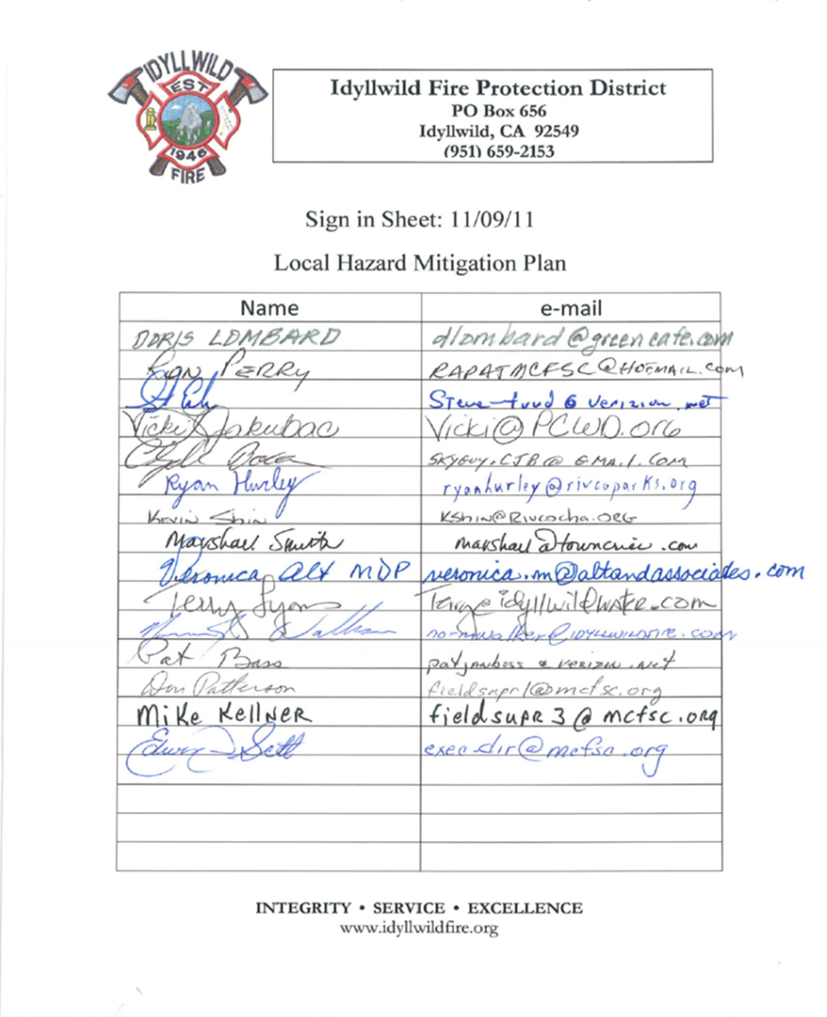

APPENDIX B - INVENTORY WORKSHEETS

APPENDIX C – PLAN REVIEW TOOL/CROSSWALK

